FUNDATMENTALS OF INTERNET

Let us understand how a internet works:

1. DNS (DOMAIN NAME SYSTEM)

--We use the Domain Name System so the web page request made from your local server or the computer can communicate to other server in some other country and

fetch the data.

--But computers always work in number system or the IP address and computers wont understand what is **WWW.Google.com**

--In order to convert that google.com to a valid IP address which a computer understand we are going to use the DNS(Domain Name System).

Let us understand in depth on how it works with pictures below:

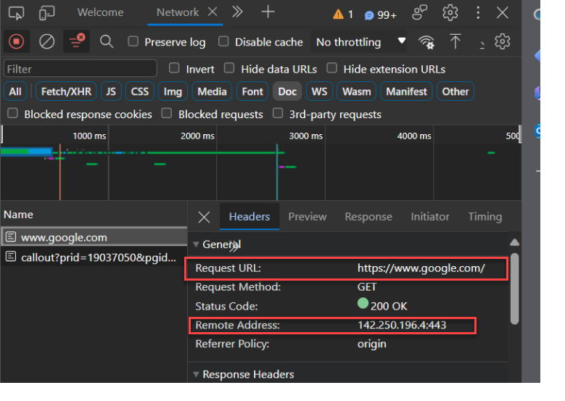

1. In the above image we can see 2 fields called the Request URL and the Request Address

-- Req URL it is showing us the google.com a

-- Remote Address is showing us the IP Address

1. Normally the computers don’t understand the human understandable language, so in order to fetch web page, we are going to use the DNS(DNS resolver) which acts as an translator between Req and the remote

Info: A DNS resolver, often simply referred to as a "resolver," is a fundamental component of the Domain Name System (DNS) infrastructure. Its primary function is to convert human-friendly domain names, like "[www.example.com](http://www.example.com/" \t "https://chat.openai.com/c/_new)," into the numerical IP addresses that computers and networking devices use to identify each other on the internet.

DNS of 2 types in generally:

1. Which is provided by our ISP provider
2. Which is manually provided by us which you can see in our routers in dns setting

Primary DNS and Alternate DNS.

So, What exactly a DNS is going to do let me explain with one more example:

**-------Initial stage of fetching the dns without catching we are going to have 4 process.**

1. **Recursive resolvers**
2. **Root name servers**
3. **TLD name servers**
4. **Authoritative name servers**

Imagine you're trying to send a letter to your friend, John, who lives in a house with a unique address. This is similar to how data is sent on the internet, with each website having a unique address (an IP address).

1. **You (The User) and the Postal Service (Recursive Resolver):**

**Your Role**: You want to send a letter from Bangalore to your friend, John, in Chennai, but you only know his name (similar to knowing a website's name, like "**www.example.com**").

**Your Helper (Recursive Resolver)**: You call your local postal service in Bangalore (**the recursive resolver**) and ask them to find John's location (similar to finding a website's location on the internet). You trust them to handle the details.

1. **The Local Post Office in Bangalore (Root Nameservers):**

**Their Role**: The local postal service in Bangalore doesn't know John's location in Chennai, but they know where to find information about addresses in Chennai.

**What They Do**: They look at a big directory (like the **root nameservers**) and tell you which central post office (**TLD nameservers**) in Chennai you should contact to find John's location. They say, "To find John in Chennai, you need to go to the central post office in Chennai."

1. **The Central Post Office in Chennai (TLD Nameservers):**

**Their Role:** The central post office in Chennai knows a lot about locations in Chennai (like "**.com**" for websites ending in ".**com**").

**What They Do:** They tell you which neighborhood (the authoritative nameservers for a specific domain) in Chennai you should go to in order to find John's location.

1. **John's Neighborhood in Chennai (Authoritative Nameservers):**

**Their Role:** John's neighborhood in Chennai is where you'll find John's location. In the internet world, this is like the server hosting the website you want to visit.

**What They Do:** When you reach John's neighborhood, you find John's location in Chennai (the IP address), which you needed to send your letter from Bangalore to Chennai.